**Ideation Phase**

**Define the Problem Statements**

|  |  |
| --- | --- |
| Date | 19 September 2022 |
| Team ID | PNT2022TMID48082 |
| Project Name | Project - Smart Waste Management For Metropolitan Cities |
| Maximum Marks | 2 Marks |

**Customer Problem Statement Template:**

Create a problem statement to understand your customer's point of view. The Customer Problem Statement template helps you focus on what matters to create experiences people will love.

A well-articulated customer problem statement allows you and your team to find the ideal solution for the challenges your customers face. Throughout the process, you’ll also be able to empathize with your customers, which helps you better understand how they perceive your product or service.

Reference: <https://miro.com/templates/customer-problem-statement/>

**Example:**

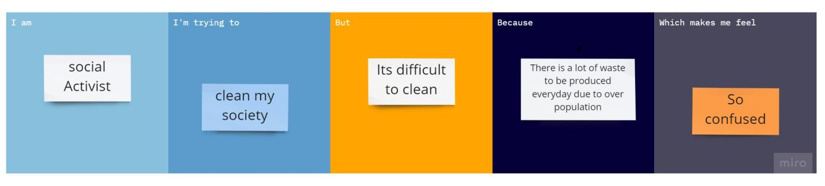

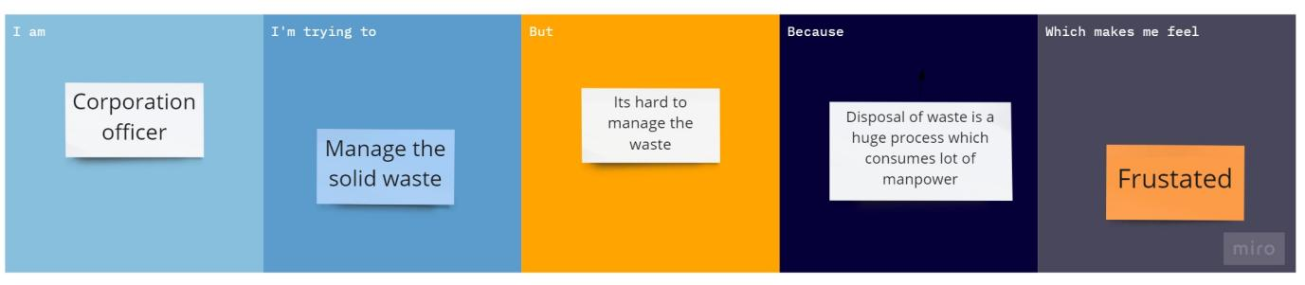

|  |  |  |  |  |  |
| --- | --- | --- | --- | --- | --- |
| **Problem Statement (PS)** | **I am (Customer)** | **I’m trying to** | **But** | **Because** | **Which makes me feel** |
| PS-1 | Social activist | Clean my society | Its difficult to clean | There is lot of waste to be produced everyday due to overpopulation | So confused |
| PS-2 | Corporation Officer | Manage the solid waste | Its hard to manage the daily waste | Disposal of waste is a huge process which also consumes lot of manpower | frustated |